Forecasting Drug Demand in Hospital Supply Chains: A Case Study of 12 Hospitals in Hamedan, Iran
This research investigates the prediction of drug demand in the supply chain of hospitals. In this work, a combined model of machine learning and time series is presented for predicting the demand of 12 hospitals in Hamedan, Iran. The model utilizes calendar and climatic features along with historical demand data for more accurate drug demand prediction. In the initial stage of this research, data augmentation was performed by transforming 4 initial features into 19 final features. According to previous research studies, all relevant climatic and temporal factors were identified and extracted, as it’s presented in Table 1. In the subsequent phase, a sophisticated model utilizing LSTM networks was employed. The suggested approach in this article introduces an ensemble model that computes the outcomes of two primary models and derives hospital consumption figures through weighted averages. One of these primary models, in addition to weather data, incorporates the drug consumption count from preceding days as an input, demonstrating commendable accuracy in the short term. Nonetheless, the iterative calculation of long-term drug consumption counts may introduce a potential for increased errors over time. Conversely, to enhance accuracy over the long term, a second model is implemented, which solely relies on weather data for predictions and exhibits superior accuracy compared to the first model in the long term. The findings indicate that the proposed ensemble model, when compared to traditional demand prediction models, achieves higher accuracy. This model, incorporating a combination of utilized models in the ensemble, demonstrates the capability to predict both short-term and long-term scenarios. By leveraging the strengths of the included models, it offers hospitals the potential to not only effectively manage their drug inventory but also anticipate and address both immediate and prolonged demands. This multifaceted approach contributes to enhancing the overall efficiency of the supply chain, allowing healthcare institutions to make informed decisions for optimal resource allocation and operational performance.
Table 1: Final features used for Model Prediction (Initial features are indicated using *)
Data Type | Description | Feature Name
Integer | Hospital index | Hospital Name*
Date | Drug Demand Date | Demand Date*
Integer | Weekly Days Index | DoWk*
Integer | Drug Order Quantity | Consumption Count*
Boolean | Closure = 1  Non-closure = 0 | School Holidays
Integer | COVID Days = 1, Peak of COVID = 2, Non-COVID = 0 | COVID-19 State
Boolean | Cold = 1 and Warm = 0 | Winter Season
Integer | Day of the Year from Start | DoY
Integer | Day of the Month from Start | DoM
Integer | Maximum Day Temperature | Max_temp
Integer | Minimum Day Temperature | Min_temp
Integer | Average Day Temperature | Temp
Float | Day Humidity | RH
Float | Day Precipitation | Precip
Float | Day Wind Speed | Wind_spd
Float | Day Solar Radiation | Solar_rad
Float | Snowfall Amount | Snow

Forecasting Drug Demand in Hospital Supply Chains: A Case Study of 12 Hospitals in Hamedan, Iran
This research explores drug demand prediction within hospital supply chains. The study introduces a hybrid machine learning and time series model to forecast the demand for 12 hospitals in Hamedan, Iran. Utilizing calendar, climatic features, and historical demand data, the model enhances accuracy in drug demand predictions. In the initial phase, data augmentation transforms four initial features into 19 final features, incorporating relevant climatic and temporal factors identified in previous research (Table 1). Subsequently, a sophisticated model utilizing LSTM networks is employed. The proposed ensemble model calculates outcomes from two primary models, combining hospital consumption figures through weighted averages. One primary model, incorporating weather data and past drug consumption, shows commendable short-term accuracy. However, iterative calculation of long-term drug consumption introduces a potential for increased errors. Conversely, a second model, relying solely on weather data, exhibits superior long-term accuracy. The ensemble model outperforms traditional demand prediction models. This model, combining various ensemble models, demonstrates the ability to predict both short-term and long-term scenarios. By leveraging model strengths, it empowers hospitals to manage drug inventory effectively, addressing immediate and prolonged demands. This multifaceted approach enhances overall supply chain efficiency, enabling informed decisions for optimal resource allocation and operational performance in healthcare institutions.
Table 1: Final features used for Model Prediction (Initial features are indicated using *)
Data Type | Description | Feature Name
Integer | Hospital index | Hospital Name*
Date | Drug Demand Date | Demand Date*
Integer | Weekly Days Index | DoWk*
Integer | Drug Order Quantity | Consumption Count*
Boolean | Closure = 1  Non-closure = 0 | School Holidays
Integer | COVID-19 Days = 1, Peak of COVID = 2, Non-COVID = 0 | COVID-19 State
Boolean | Cold = 1 and Warm = 0 | Winter Season
Integer | Day of the Year from Start | DoY
Integer | Day of the Month from Start | DoM
Integer | Maximum Day Temperature | Max_temp
Integer | Minimum Day Temperature | Min_temp
Integer | Average Day Temperature | Temp
Float | Day Humidity | RH
Float | Day Precipitation | Precip
Float | Day Wind Speed | Wind_spd
Float | Day Solar Radiation | Solar_rad
Float | Snowfall Amount | Snow

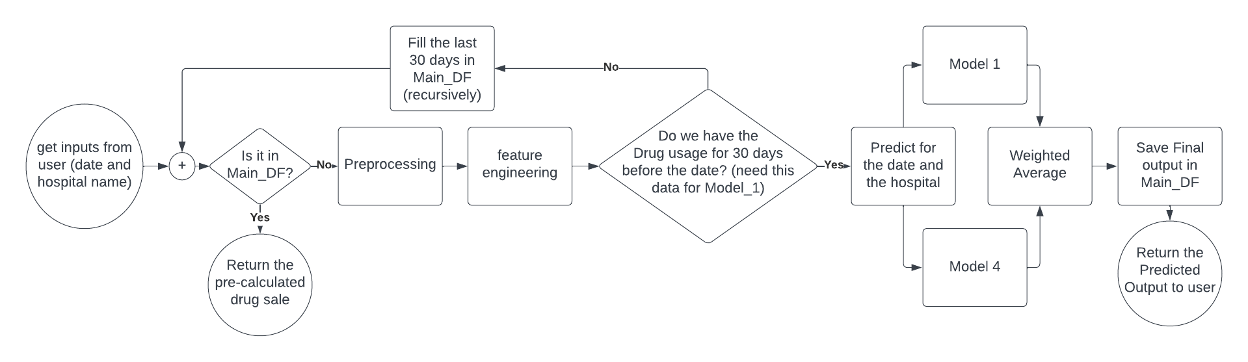
Figure 1: Flowchart of the drug demand forecasting process of proposed model

